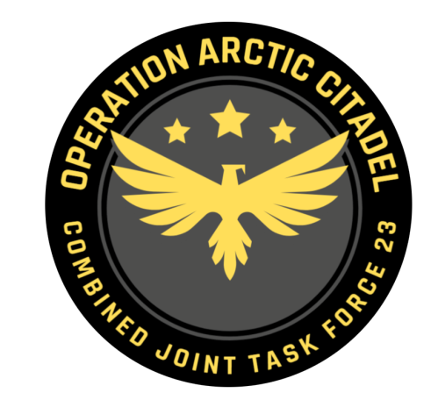

Joint Force Commander CJTF-23

DIRECTION AND GUIDANCE

D4
This document covers the friendly situation from D3 and provides CJTF-23 guidance to the entire force for D4.
Reference CombatFlite: https://132nd-vwing.github.io/OPAC-Brief/SITUATION/Friendly%20Situation.cf

SITUATION

General situation
Road to war according to introduction brief: Operation Arctic Citadel Introduction Brief

D0: September 20th 2011:
JFACC initiated intelligence gathering related to the situation, and completed phase 1 (Deployment) into theater. LCC started deployment of IV Corps into Finland and are continuing force buildup.

D1: September 21st 2011:
JFACC initiated deterrence of Notian forces, but deterrence was unsuccessful. SEAD/DEAD conducted toward high-end SAMs in 1st and 3rd Corps area, while conducting attacks at HQs as part of slowing down enemy advance.
LCC moved into contact with Notian forces at the end of D1 at three locations.

D2: September 22nd 2011:
JFACC moved into phase 3a: Defence of Notia and established CAPs to protect the airspace from Notian incursions. In addition the CAPs protected friendly ground forces and airbases from Notian attacks. JFACC also initiated AR and CAS flights to support against Notian ground forces moving into Finland. JFACC also executed SEAD/DEAD and BAI to shape for further action.
D3: September 23rd 2011:

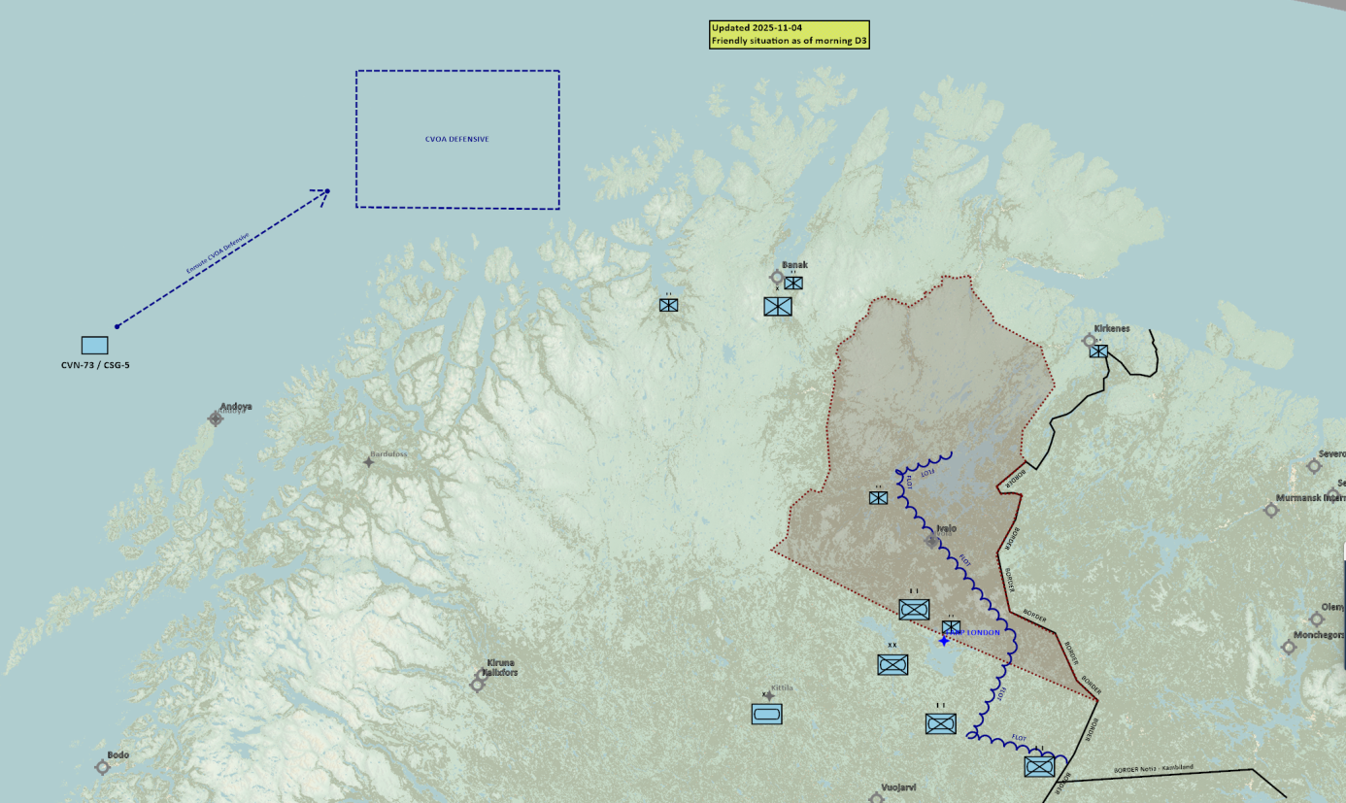

Friendly situation

Land Component Command (LCC)

IV Corps

55th Armor Division (Abrahams and Challenger 2 tanks)
Currently in reserve located around Kittila.

56th Mechanized Division (M2A2 Bradley, LAV-25 and Humwee’s)
Lead elements of the 56th Division have established contact with the enemy in three locations:
BN 1: Heavy fighting IVO IVALO (airfield)
BN 2: West of Lokka
BN 3: Northwest of the border between Notia, Kambiland and Finland

Finnish local forces
- The Finnish 33rd Brigade (M-113s)
- First BN –Withdrawn to Inari.
- Second BN- located IVO FARP LONDON.

Norwegian local forces
- The Norwegian 44th Brigade (M-113s, Leopard and Bradley)
- First BN (Bradley IFV) – Located IVO Kirkenes
- Second BN (M113 APC) – Located IVO Banak
- Third BN (Leopard MBT – Located IVO Alta

Maritime Component Command (MCC)
- CVN-73/CSG-5 now enroute CVOA DEFENSIVE. On station CVOA end of D3.1

Special Operations Component Command (SOCC)
- SOF teams are standing by to support with reconnaissance as required.
- SOF teams are also on standby to conduct counter terrorism missions and counter insurgency operations.

Reported Battle Damage Assessment

IV Corps Northern Sector
- 5x Main Battle Tanks

Finnish local forces.
- 3x BMP-3

Norwegian local forces.
- NSTR

Logistical situation
Available ordnance: https://132nd-vwing.github.io/OPAC-Brief/MISSION%20INFORMATION/OPAC%20Ordnance.pdf

Direction and Guidance

LCC:
- Defend against Notian invasion and be prepared to retake land in claimed Notian territory.

MCC:
- Recover FW jets from 494th and 108th after sorties on D3.1

JFACC:
- Apportionment
  - Per JFACC priorities
- JFACC are now in phase 3a DEFEND.
- Priority of effort is to establish air superiority
  - Shape battlefield to facilitate for long range strikes into Notia to conduct offensive counter air against airbases
  - Shape battlefield to facilitate for long range strikes into Notia to strike factories for air defence

VIS:
- Support JFACC with planning and execution of campaign.
  - Be prepared to support JFACC with phase 3a and 3b planning
- Recommend to JFC changes in diplomatic status for any country during target meeting.

Diplomatic situation
- Notia is declared as enemy
- Kambiland is declared as neutral
- Xilong is declared as adversary
- DUSS is declared as adversary
- The Iron Resolve is declared as enemy
- The Dawn’s Vengeance is declared as adversary

Only units declared as enemy can and should be engaged by CJTF forces.

Definitions:
Enemy: is actively opposed or hostile to CJTF and friendly forces.
Adversary: opponent in a contest, conflict, or dispute toward CJTF and friendly forces.
Neutral: not supporting or helping either side in a conflict, disagreement, etc.; impartial.

Joint Force Air Component Commander – Commander of all air forces (player volunteers)
Land Component Commander – Commander of all land forces
Naval FW jets will depart from Banak, but can recover at CVN-73 D3.1. For D3.2: Naval FW jets can both depart and recover at CVN-73
Air apportionment is the determination and assignment of the total expected effort by percentage and/or priority that should be devoted to the various air operations and/or geographic areas for a given period of time.

